**MS SQL SERVER**

**Standard Operating Procedures**

**(SOP)**

**Restore database through TDP**

Submitted to



**By**



CIS, Wipro Limited

Document Details

|  |  |
| --- | --- |
| Project Name | Innogy SE |
| Account | CIS |
| IT Component/Application Title | Restore database through TDP |
| Current Version | 1.2 |
| List of Contributors | Pradipkumar Kansara, Kiran Bhalekar, Ayushi Gautam, Sivakumar Goud, Shikha Verma, Pramod Patil |
| Customer Contact Information |  |

Version History

(All revisions made to this document must be listed in chronological order. All revisions must be approved. Review and Approval can be done by an internal source or by the customer)

|  |  |  |  |  |  |
| --- | --- | --- | --- | --- | --- |
| Version | Date of Revision | Description | Author | Reviewed By | Approved By |
| 1.0 | 07-02-2018 | Initial Draft | Kiran Bhalekar | Pradipkumar Kansara | Santosh Badiger |
| 1.1 | **08-02-2018** | **Document Completed** | **Kiran Bhalekar** | **Pradipkumar Kansara** | **Santosh Badiger** |
| 1.2 | **05-10-2018** | **Updated the content** | **Pramod Patil** | **Pradipkumar Kansara** | **Santosh Badiger** |

Document Distribution List

|  |  |  |
| --- | --- | --- |
| **Sr.No** | **Name and Company** | **Purpose** |
| **1** | RWEIT-SQLDBA | **This document is useful in understanding how we restore database through TDPSQL backup GUI** |

**TABLE OF CONTENT**

1. Purpose 4

2. Scope 4

3. Administor configuration during installation 4

4. Reference 7

# 

# Purpose

This document is to cover the process of doing restoration of database through SQL TDP.

# Scope

This document is prepared for GSMC Wipro sustenance team and provides the concepts of access management for SSAS.

# Restoration process through SQL TDP:

TDP SQL is a tool which we use to take backup of databases. TDP SQL will not create any backup file(i.e. .bak file), however it will directly take backup of data files(.mdf, .ndf files) to TSM server.

Now we will see how we can do restoration of database through TDP SQL. We will follow below steps to do restore.

**Please fine below process to check the availability of database backup and then to restore it.**

Go to the patch ‘C:\TSM\TDPSql’ and open ‘tdpsql.exe’ file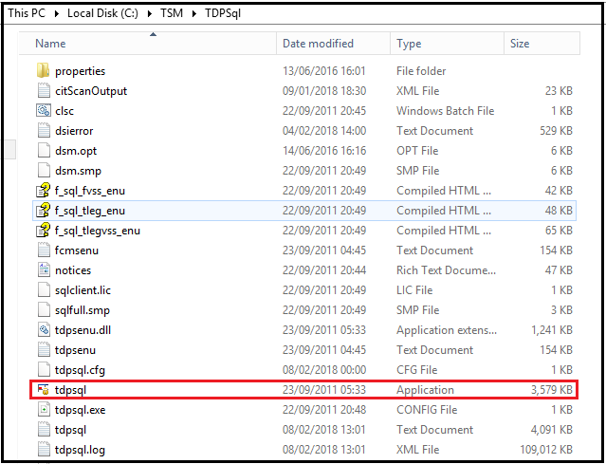

Now TDP SQL window will get open and you will see below page

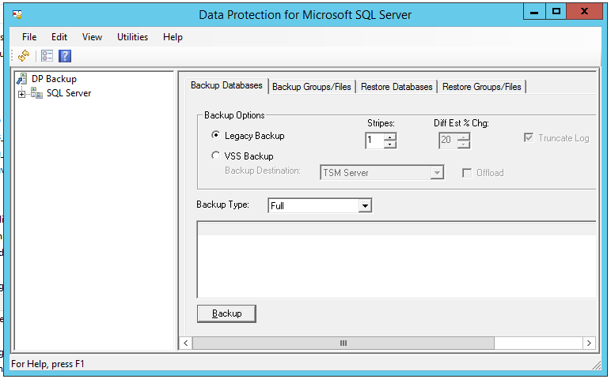

Expand the tree at upper left corner where SQL server is written. After expanding the tree you will be able to see the instances which have been configured for online SQL TDP with its database list as shown in below screenshot:

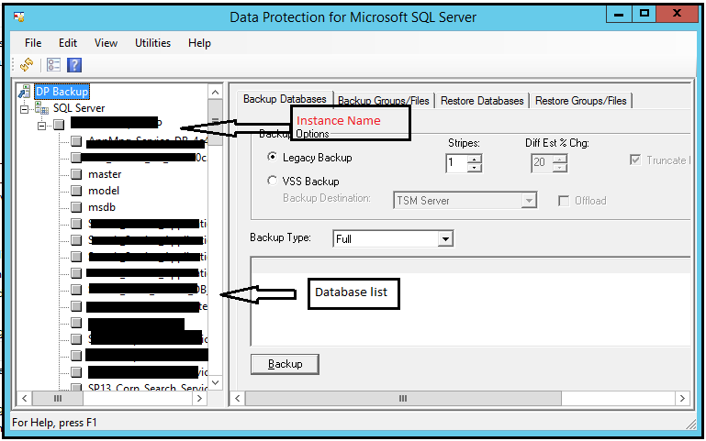

In above screenshot, you are able to see 4 tabs as follows:

1. Backup databases
2. Backup Group/Files
3. Restore databases
4. Restore Group/Files

Click on ‘Restore databases’ option. You will see the instance-database tree at left. Check the checkbox where it is written ‘show active and inactive’

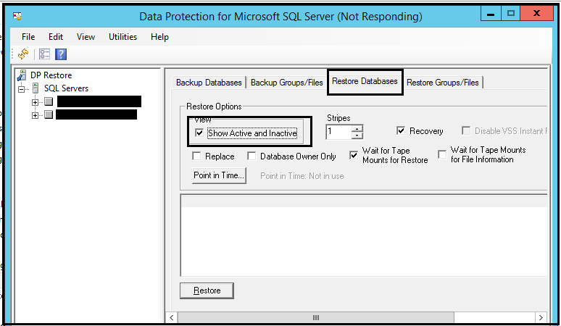

Expand the tree and select the database to restore. Once you click on that database you will be able to see all the available backups for that database as shown in below screenshot:

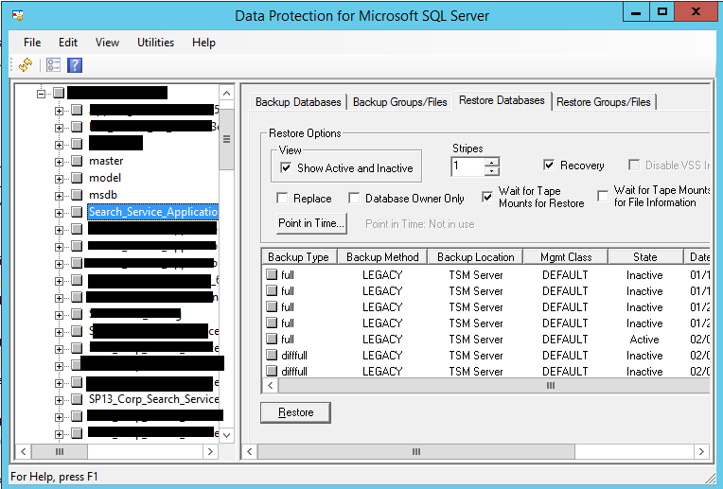

Select the backup of the specific date which you want to restore and then click on restore.

Your database will get restored as per the data which was there in that database backup.

# References:

<http://www.tsmtutorials.com/2014/01/sql-backup-restore-using-tdpsql.html>